Mortar Assembly 

Objective:

1. Wing Knob Assembly 13015690 Rev C

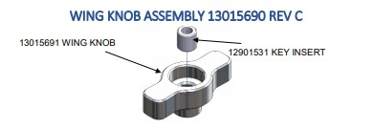

Figure 1 Wing Knob Assembly

* 1. Assemble 12901531 Key Insert into 13015691 Wing Knob until inserted to 0.3 + 0.5 [mm below surface as shown on drawing 13015690 Wing Knob Assembly. (Figure 1)](https://testv2.proceduregenius.com/testing/procedurereference?file=wing-knob-assembly-13015690-rev-c.png)
  2. Insert pins flush with 12901531 Key Insert body to permanently lock in

[place. (Figure 1)](https://testv2.proceduregenius.com/testing/procedurereference?file=wing-knob-assembly-13015690-rev-c.png)

1. Cross Leveling Clamp Assembly 13017550 Rev E

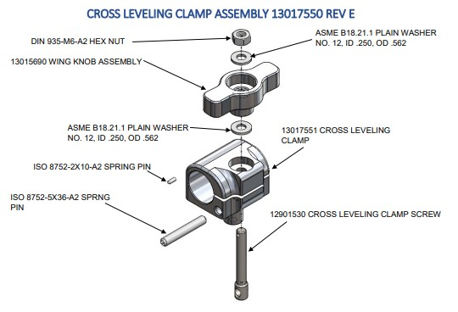

Figure 2 Cross Leveling Clamp Assembly

* 1. Insert 12901530 Cross Leveling Clamp Screw into 13017551 Cross Leveling Clamp [and rotate until hole in Screw aligns with hole in Clamp. (Figure 2) (procedurereference?file=cross-leveling-clamp-assembly-13017550-rev-e.png)](https://testv2.proceduregenius.com/testing/procedurereference?file=cross-leveling-clamp-assembly-13017550-rev-e.png)
  2. Press ISO 8752-5x36-A2 Spring Pin into 13017551 Cross Leveling Clamp and through hole in Cross Leveling Clamp Screw, until seated below surface of [Clamp. (Figure 2)](https://testv2.proceduregenius.com/testing/procedurereference?file=cross-leveling-clamp-assembly-13017550-rev-e.png)
  3. Place one ASME B18.21.1 Plain Washer over the 12901530 Cross Leveling Clamp [Screw. Then thread 13015690 Wing Knob Assembly on until lightly seated. (Figure](https://testv2.proceduregenius.com/testing/procedurereference?file=cross-leveling-clamp-assembly-13017550-rev-e.png)

[2)](https://testv2.proceduregenius.com/testing/procedurereference?file=cross-leveling-clamp-assembly-13017550-rev-e.png)

* 1. Place second ASME B18.21.1 Plain Washer over Screw and top with DIN 935-M6- [A2 Hex Nut. Thread on until lightly seated. (Figure 2)](https://testv2.proceduregenius.com/testing/procedurereference?file=cross-leveling-clamp-assembly-13017550-rev-e.png)
  2. Turn Hex Nut counter clock wise until slot in Nut lines up with hole in Screw. Press ISO 8752-2X10-A2 through slot in Hex Nut and into hole in Screw until flush with [Hex Nut. (Figure 2)](https://testv2.proceduregenius.com/testing/procedurereference?file=cross-leveling-clamp-assembly-13017550-rev-e.png)

1. Left Leg Foot Installation

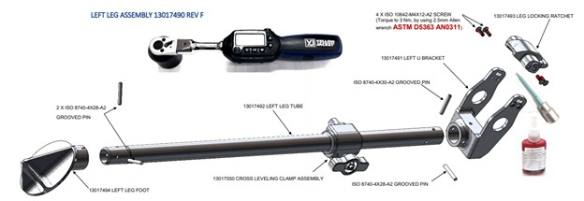

Figure 3 Left Leg Foot Installation

* 1. Apply ASTM D5363 AN0421 Retaining Compound to the inside diameter of [13017494 Left Leg Foot and install onto 13017492. (Figure 3)](https://testv2.proceduregenius.com/testing/procedurereference?file=left-leg-foot-installation.png)
  2. Consult drawing 13017490 to ensure correct orientation and drilling instructions. [(Figure 3)](https://testv2.proceduregenius.com/testing/procedurereference?file=left-leg-foot-installation.png)
  3. Press 2 X ISO 8740-4X28-A2 Grooved Pins into drilled holes until fully seated. [(Figure 3)](https://testv2.proceduregenius.com/testing/procedurereference?file=left-leg-foot-installation.png)
  4. Install 13017550 Cross Leveling Clamp Assembly over 13017492 Left Leg Tube. [(Figure 3)](https://testv2.proceduregenius.com/testing/procedurereference?file=left-leg-foot-installation.png)
  5. Insert 13017493 Leg Locking Ratchet into 13017491 Left U Bracket in orientation as [shown. Ensure to engage tabs on sides of Ratchet into slots in U Bracket. (Figure 3)](https://testv2.proceduregenius.com/testing/procedurereference?file=left-leg-foot-installation.png)
  6. Apply ASTM D5363 AN0311 Anaerobic Adhesive to 4 X ISO10642-M4X12-A2 Countersunk Screws and install in four holes in 13017493 Leg Locking Ratchet. [(Figure 3)](https://testv2.proceduregenius.com/testing/procedurereference?file=left-leg-foot-installation.png)
  7. [Torque to 3 Nm, by using 2.5mm Allen wrench. (Figure 3)](https://testv2.proceduregenius.com/testing/procedurereference?file=left-leg-foot-installation.png)

1. Left U Bracket installation
   1. Apply ASTM D5363 AN0421 Retaining Compound to inside diameter of 13017491 Left U Bracket and install over 13017492 Left Leg Tube.
   2. Consult drawing 13017490 to ensure correct orientation and drilling instructions.
   3. After drilling press ISO 8740-4X30-A2 Grooved Pin and ISO 8740-4X28-A2 Grooved Pin into holes until fully seated.
2. Step Title
   1. Place the assembled leg into the model
   2. Expand the model as a whole to see all components
   3. Exit Procedure